Week 7 Go and Rust Programs

Robert Brenckman
Charter Oak State College
ITE 215: Software Develop Method & Languages
COSC_ITE215012526FACR
John Rusnak
12/07/2025

Assignment Instructions:

Create a Go program that performs the following:
- Prompt the user to enter two integers.
- Read the integers from the user input.
- Compute the sum of the two integers.
- Display the result to the user.
Create a Rust program that performs the following:
- Prompt the user to enter two integers.
- Read the integers from the user input.
- Compute the sum of the two integers.
- Display the result to the user.

Rust
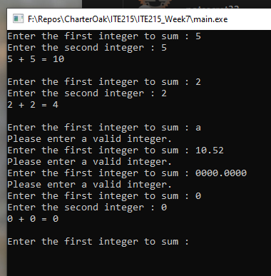

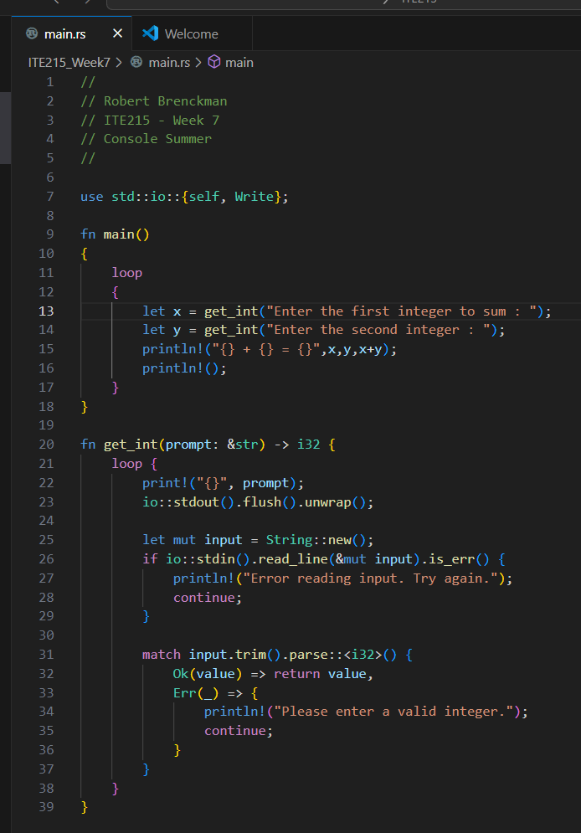

Go (Run within VS-Code Terminal)
